HW03 學號:309515021 姓名:黃浩瑋

1. 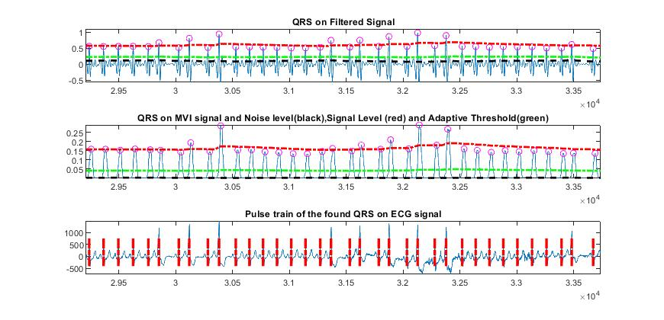(1) Ecg1 是 PVC,
2. 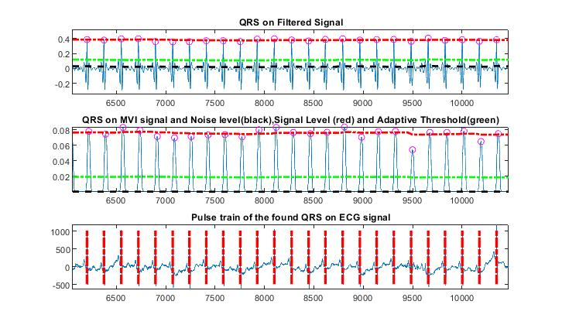Ecg2 是Normal.
3. 取 ecgpvc.dat 的檔案做運算  
   [qrs_amp_raw,qrs_i_raw,delay]=pan_tompkin(ecg,fs,1);

PT = qrs_i_raw;

newPT = [];

for i = 1 : length(PT)-1

newPT = [newPT PT(i+1)-PT(i)]; %計算RR Values

end

RR_AVG = mean(newPT);

RR interval average : **125.13ms**  
[qrs_amp_raw,qrs_i_raw,delay]=pan_tompkin(ecg,fs,1);

PT = qrs_i_raw;

FFAVG = [];

for i = 1 : length(PT)-1

RR_RMS = rms(ecg(PT(i):PT(i+1)));

RR_AVG = mean(ecg(PT(i):PT(i+1))); %第二題 RR AVG

FF = RR_RMS/RR_AVG; % 第二題 FF

FFAVG = [FFAVG FF];

end

FF_AVG = mean(FFAVG);

Form factor (FF) :取每段RR之間的波做FF 值為**1.0064**

1. Use a duration of 80 samples (400 ms) spanning the QRS - T portion of each beat to compute FF.

取第14752~14832點

RR_RMS = rms(ecg(14752:14832));

RR_AVG = mean(ecg(14752:14832));

FF = RR_RMS/RR_AVG;  
**FF = 1.0256**

1. The P wave need not be considered in the present exercise. Compute the mean and standard deviation of the FF and RR values for the normal beats and the PVCs. Evaluate the variation of the two parameters between the two categories of beats.

Data ECG1: RR_Value std = 0.1182 / RR_Value mean = 0.5835  
 FF std = 0.0038 / FF mean = 1.0064  
Data ECG2: RR_Value std = 0.1080 / RR_Value mean = 0.4135  
 FF std = 0.0051 / FF mean = 1.0062

